System : Information System
Company/Office : Kean Gabriel Hotline.
Project Stage : Requirements Specifications and Conceptual Data Model
Date : July 17, 2017
Class & Section : IT-12 MWF, 9:00 – 10:00AM & 1:00-2:00PM
Group Name : Upaw
Group Members : John Mar Lorenzo, Jhon Lloyd Gellica, Marc Andrew Betonio,
Reylar Rebuta

Project Stage : Analysis
Project Title : Requirements Specifications and Conceptual Data Model
Deadline : 17 July 2017

- REQUIREMENTS SPECIFICATION

- Requirements Phase
- Introduction
Being adjudged by the National Children’s Welfare Council as Community of Practice for Children, the City Government pursues its strong commitment to uphold the rights of children by pursuing the establishment of a Child Abuse Hotline. This hotline is a point-to point preselected destination link that automatically connects the caller/victim to the concerned agency and response team dedicated to respond and/or prevent child abuse in the community.

The name of the hotline is in memory of Kean Gabriel, a three (3) year old child residing in Matina Pangi who was a victim of child abuse by his parent and guardian. Sometime in 2016, Kean was beaten, placed in a sack and suspended on a wooden cabinet by his stepfather and fell several times. After falling, the child suffered from hemorrhage which resulted to his instantaneous death. Both his stepfather and mother were thereafter jailed for child abuse.

The hotline is thus established to provide prompt intervention by providing a 24-hour facility for the reporting of all types and forms of child abuse. Same will be launched on October 29, 2016—the 40th day of Kean’s death.

- Current System Overview
System starts with a call from a referral party (e.g. Central 911, Police Station, Radio, GOs/NGOs, Concerned citizens) to Kean Gabriel Hotline. After receiving the call and acquire some information from the referring party, the Kean Gabriel Hotline will request for a Police and Barangay assistance with QRTCC (Quick Response Team for Children’s Concern).

After rescuing the victim, the QRTCC’s workflow follows.

- The walk-in process starts with a referral party and report the incident directly to the QRTCC. After acquiring some information from the referring party, the QRTCC will then send a rescuer together with the help of the Police and barangay officials in the area.

- Identified Risks
- Slow computation of statistics.
- Need to find the records in a logbook.

- User Requirements
- Records data
- User Authentications.
- Statistics.

Nonfunctional Requirements:
- User Friendly
- Reliable
- Usability
- Security

- Specifications Phase

System Overview
- The proposed system for Kean Gabriel Hotline is an Information System which specifically has: Information System for the user not to be hassled with sorting a specific record and can easily record a data for a case, User Authentication because the data of the organization is confidential, and Statistics because the computation for the monthly statistic can take up for about 2 weeks to be done.

Capabilities and Limitations

The Information System’s capabilities are; Records information/data easily and virtually, search specific data without hassle, sorting data by its date, cases, etc., generates monthly and yearly statistics to give report immediately.

The Information System’s limitations are; It cannot delete data since it is not advisable to delete data from the database, it can only search data according to users specified information.

3. Hardware & Software Specification

Processor: AMD Dual Core, Intel Dual Core @ 1.8Ghz or Higher
RAM: 2GB or higher
OS: Windows 7 / 8 / 8.1 (32/64 bit)
Free Disk Space: 50mb

4. User Specification

• Should be Computer literate.

II. CONCEPTUAL DATA MODEL
- Identified User Views

Blank Form
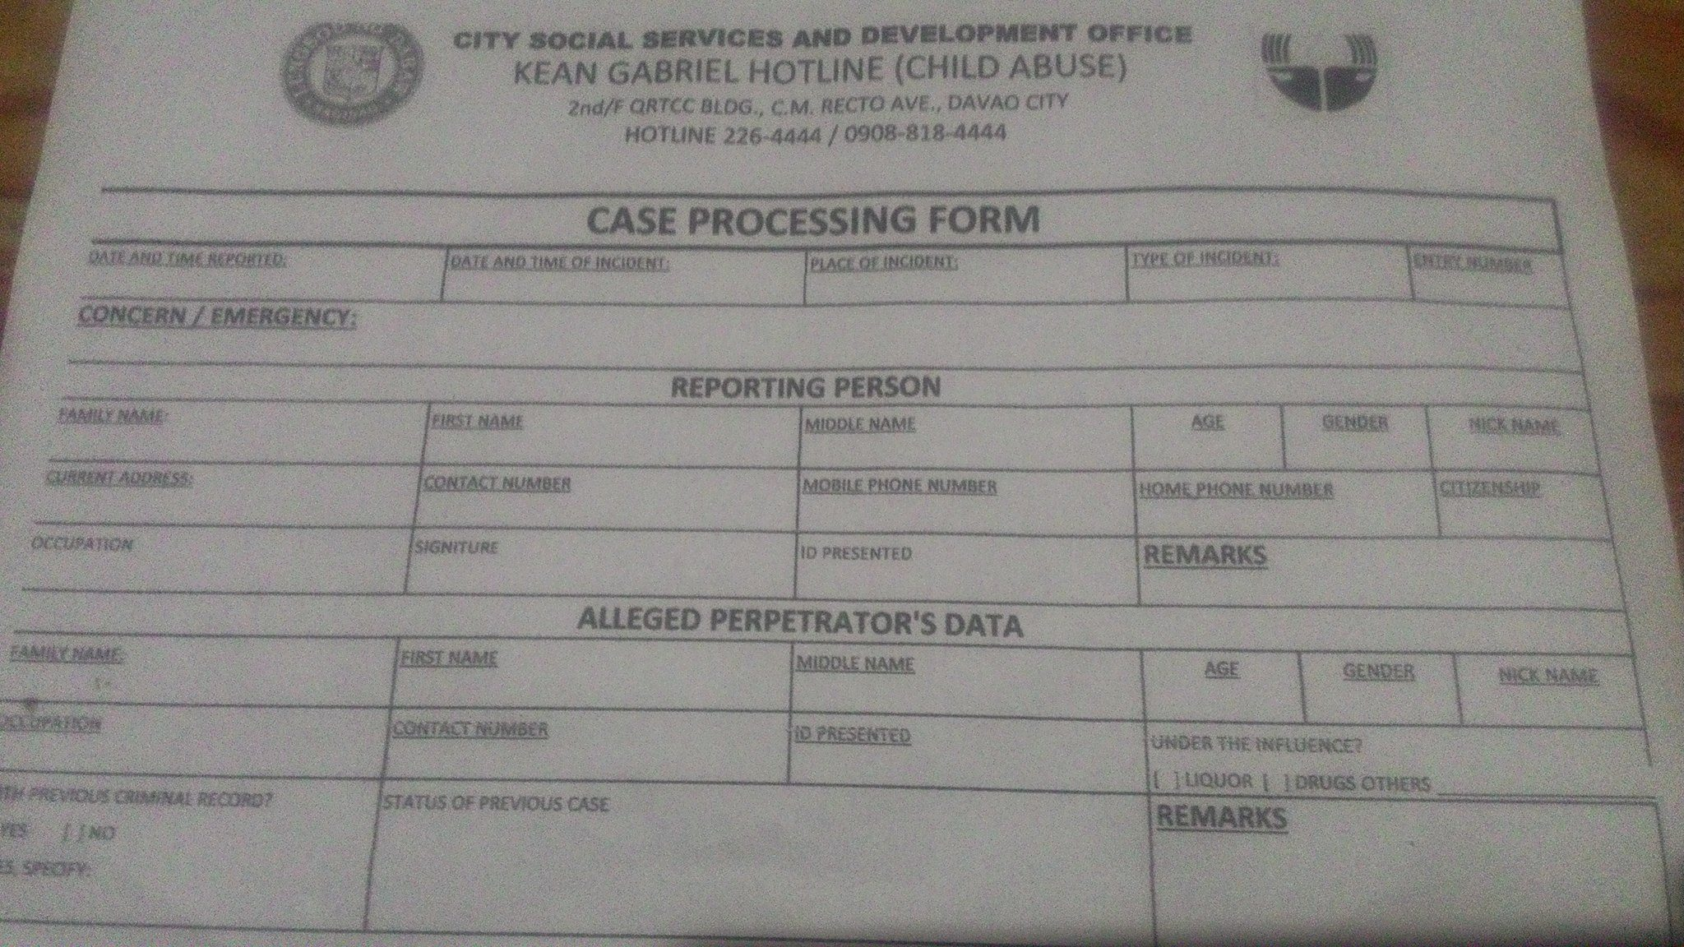

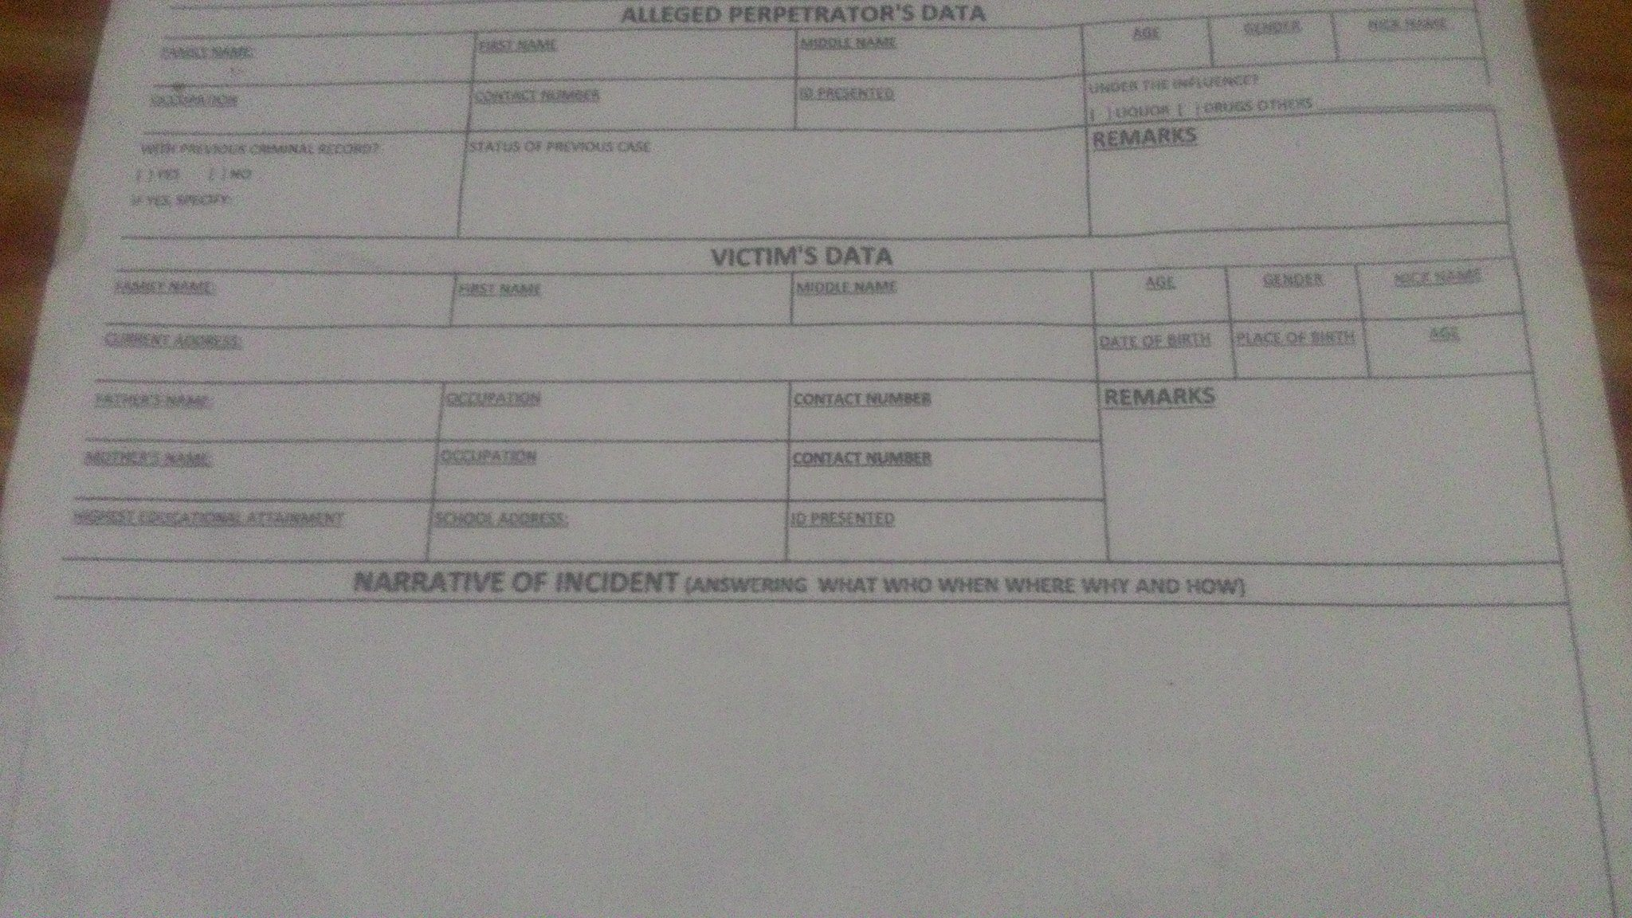

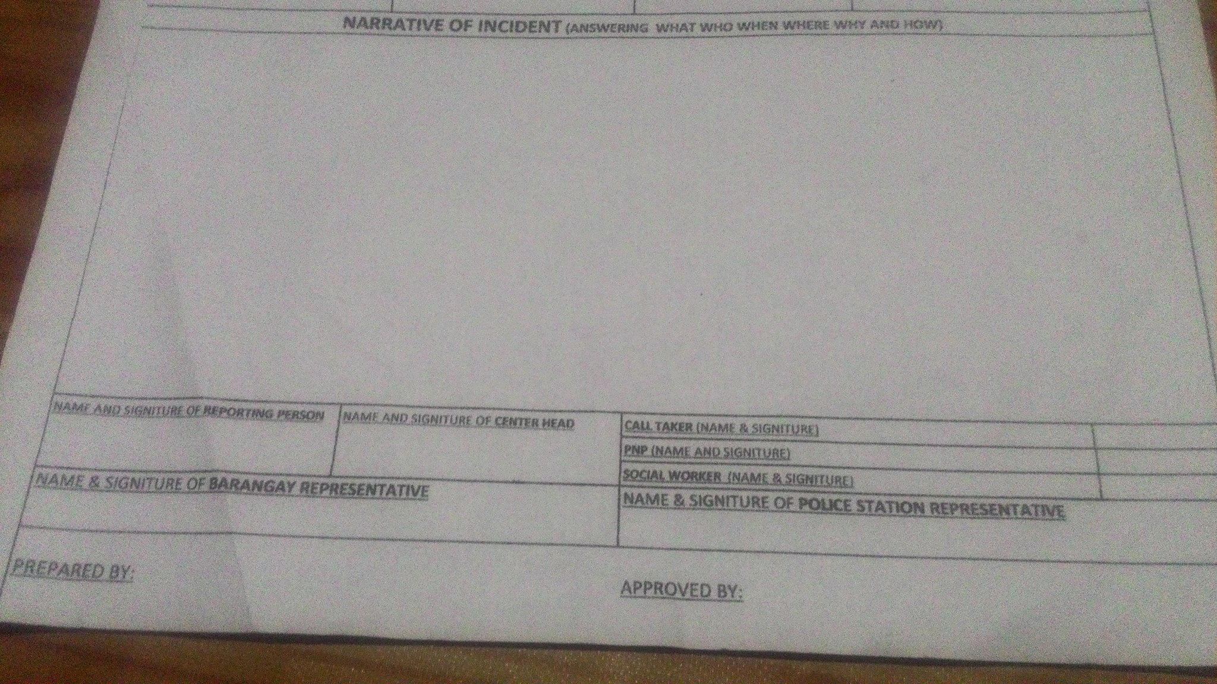

User view summary from interview:

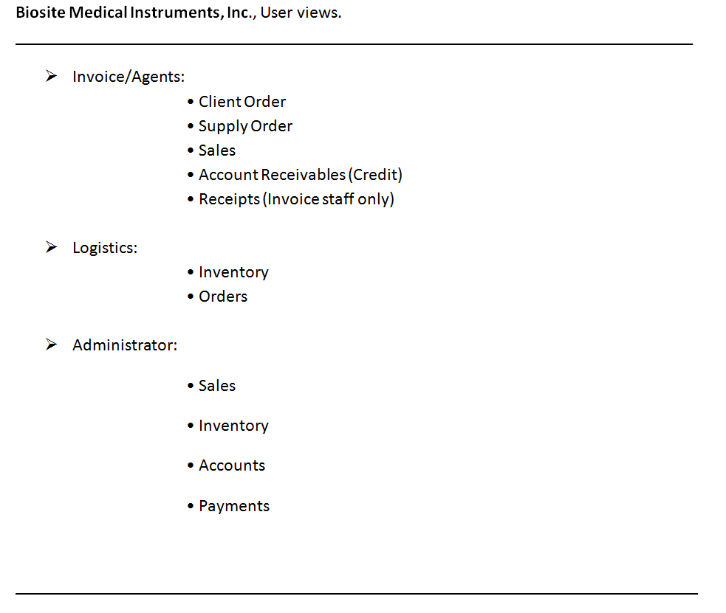

- Conceptual Data Model

1. Client order

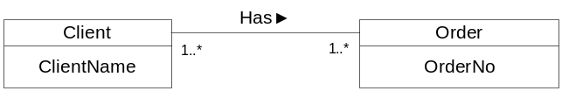

2. Invoice

3. Inventory

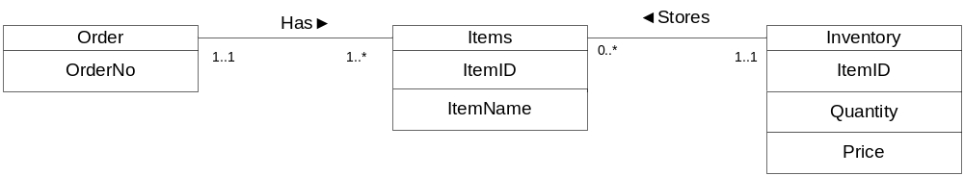

4. Supplier

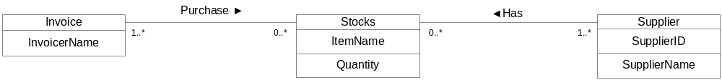
5. Administrator
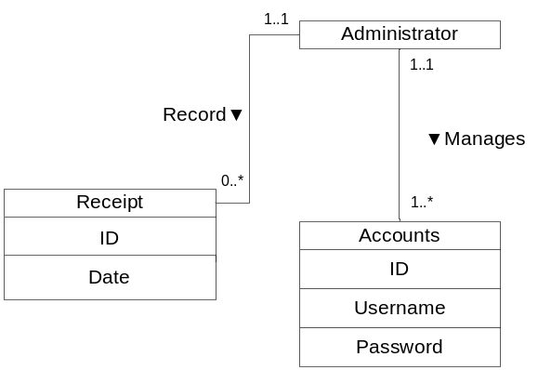

6. Kean Gabriel Hotline’s ERD.
tbPersonRepContact
personRepID
contactNum
mobileNum
homeNum
tbPerpetrators
PerpetratorID {PK}
LastName
FirstName
MidName
Age
dateOfBirth
placeOfBirth
Gender
NickName
Occupation
ContactNumber
PresentedID
UnderInfluenceOf
PrevCrimeRec
PrevCaseStat
Remarks
tbVictimDetails
VictimID
FatherName
FathOccup
FathNum
MotherName
MothOccup
MothNum
HEAttained
SchoolAdd
PresentedID
Remarks

tbVictim
VictimID {PK}
LastName
FirstName
MidName
Age
Gender
NickName
DateOfBirth
PlaceOfBirth
CurrentAddress

tbCases
caseNo {PK}
VictimID
PerpetratorID
personRepID
dateTimeRep
dateTimeIncident
placeOfIncident
typeOfIncident
entryNum
status
tbPersonReporting
personRepID {PK}
LastName
FirstName
MidName
Age
dateOfBirth
placeOfBirth
NickName
currentAddress
Occupation
PresentedID
Remarks
tbNarat
caseNo
What
Who
narat_When
narat_Where
Why
How
callTaker
socialWorker
pnp
policeRep
barangayRep
prepBy
apprvedBy
apprveStat

Project Stage : Design
Project Title : Logical Database Design and Physical Database Design
Deadline : 31 July 2017

- LOGICAL DATABASE DESIGN

1.1 FINAL INPUT SCREENS AND FINAL OUTPUT REPORTS/SCREENS
1. Login Authentication Form.
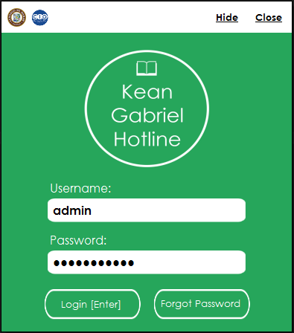
2. Selection Menu
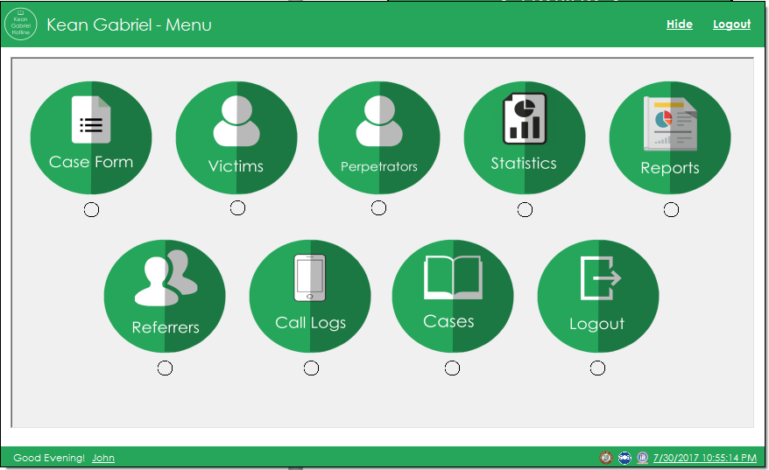
2. Case Form(On Person Reporting tab)
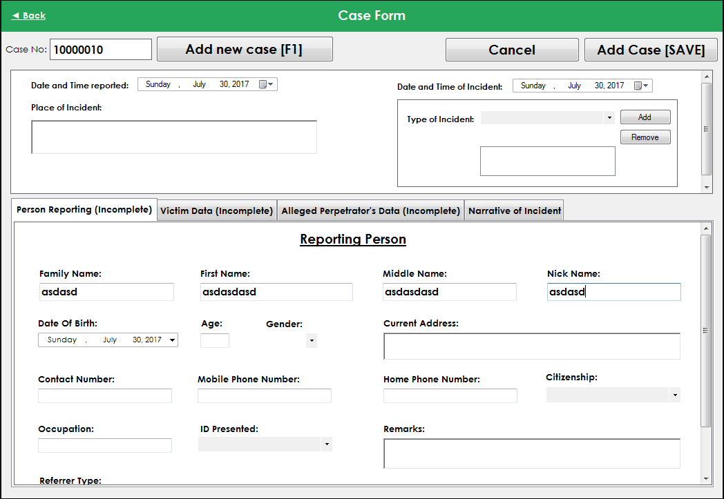
3. Case Form(On Victim Data Tab)
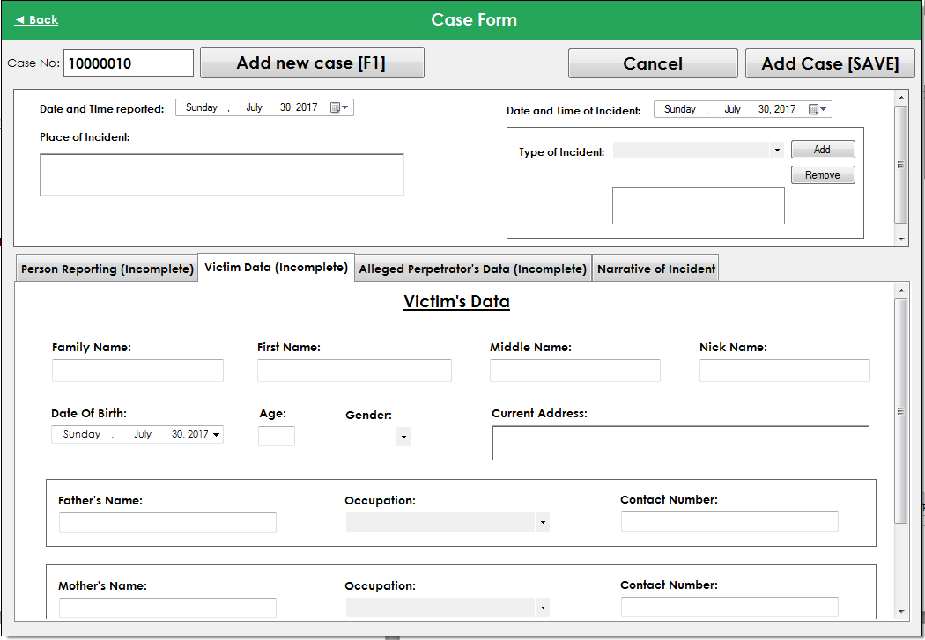

4. Case Form(On Alleged Perpetrator’s Data Tab)
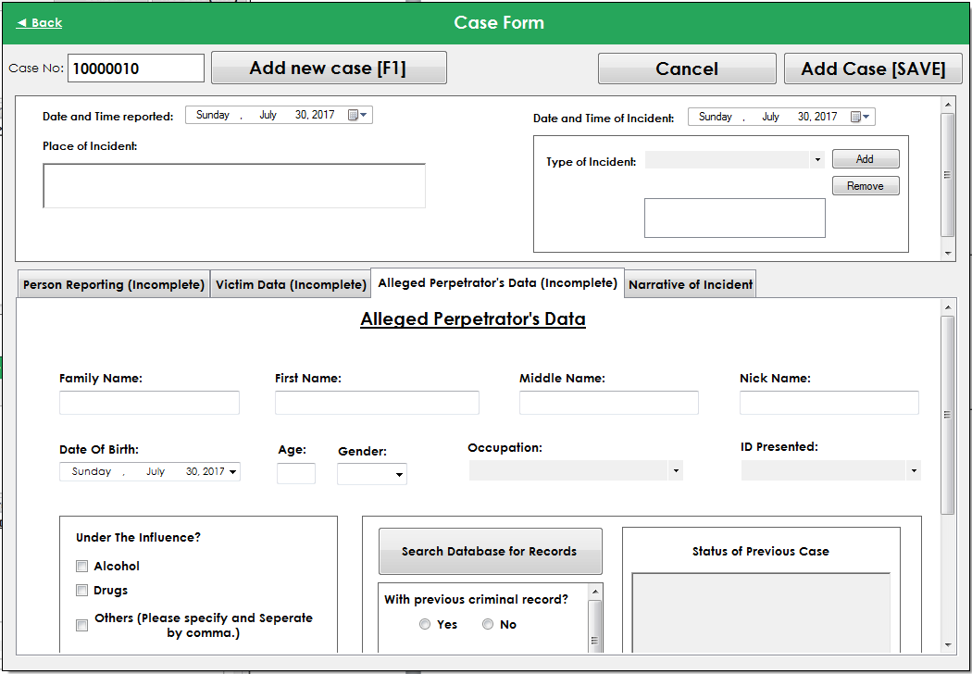
5. Case Form(On Narrative of Incident Tab)

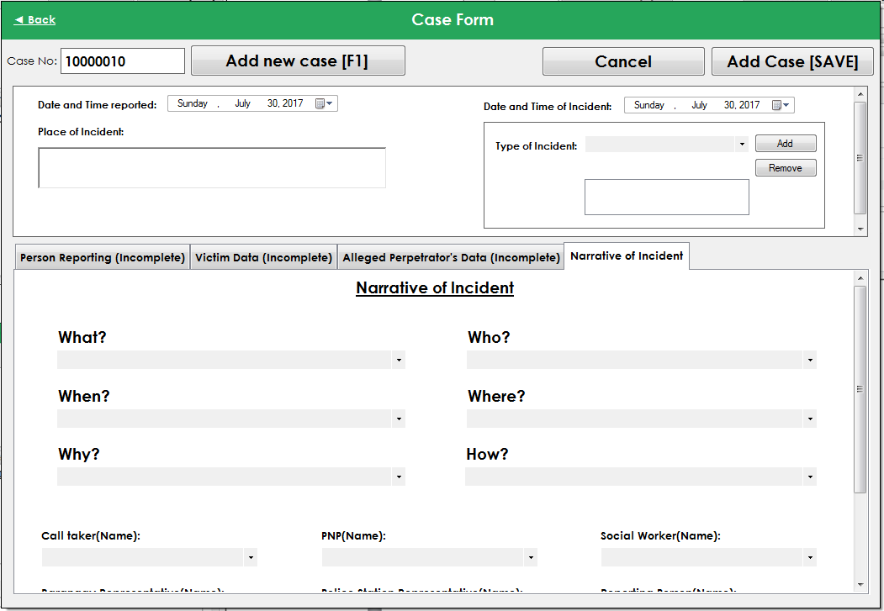

6. Victim Form
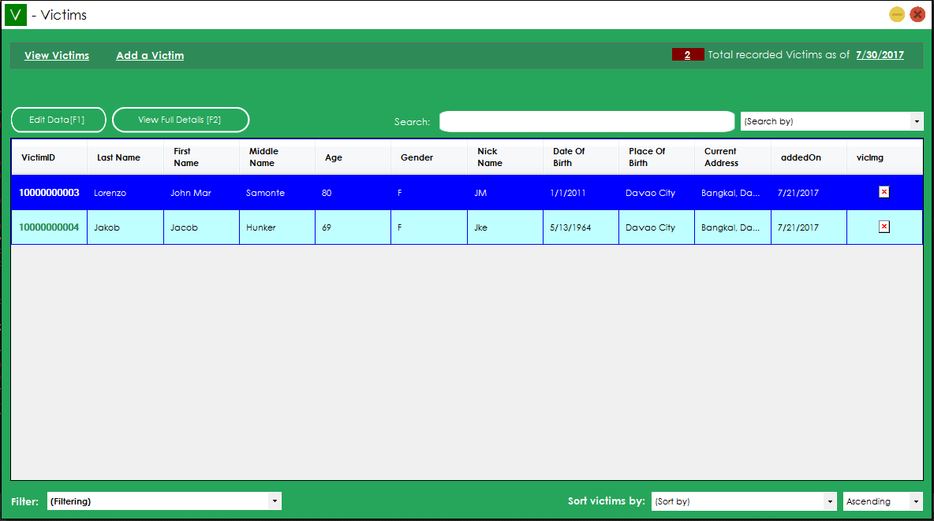
7. Perpetrator’s Form
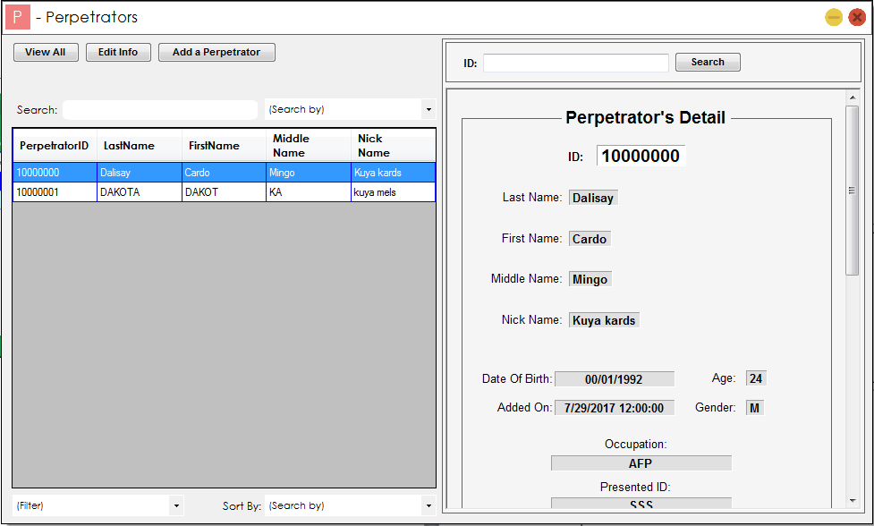

8. Invalid Account Dialog
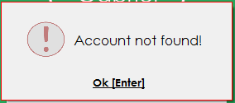
9. Error on database connection Dialog
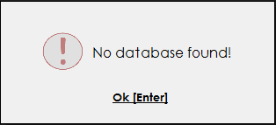
10. Call Logs Form
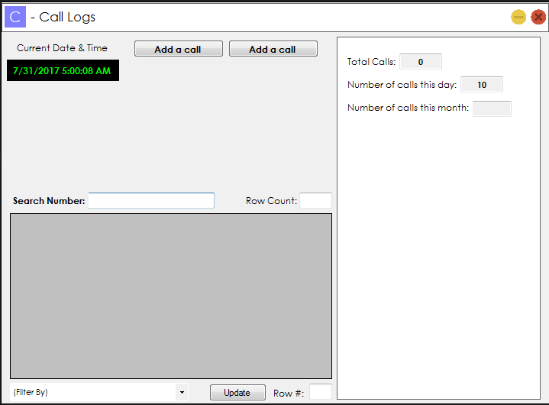

FINAL ERD

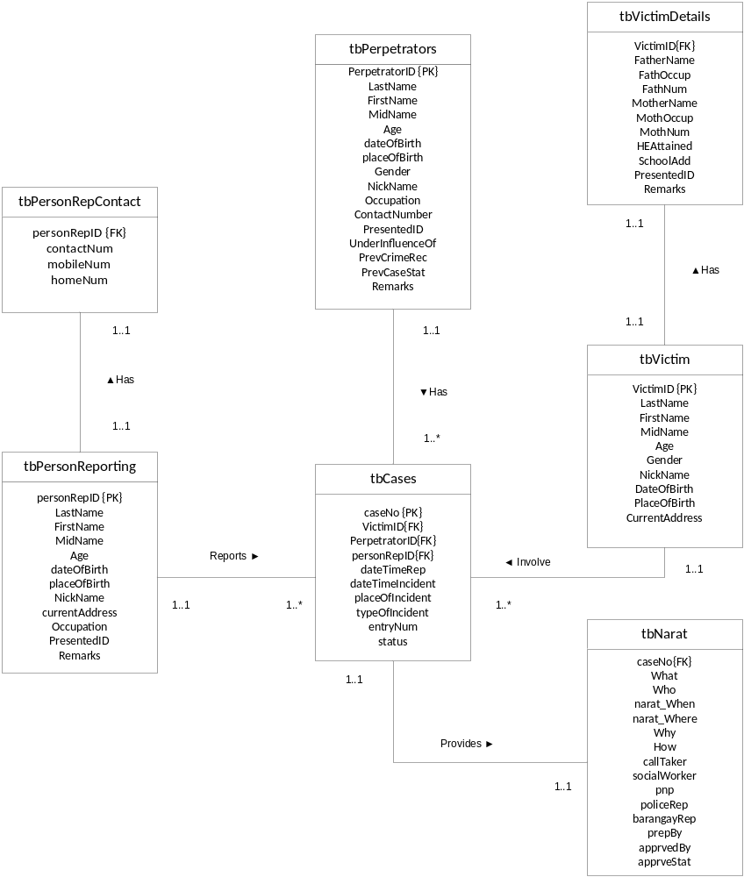
DATA DICTIONARY

Entity Name (table name): Billing
Attribute | Description | Type | Size | Null | Unique | Part_ of_PK | Foreign Key | FK_Relation
BillingID | Customer Billing ID | Integer |  | No | Yes | Yes | No
InvoiceID | Invoice ID | Integer |  | Yes | No | No | Yes | Invoice
TotalVat | Total Value added tax | Money |  | Yes | No | No | No
Total | Total Amount | Money |  | Yes | No | No | No
DiscountPhp | Discounted Php amount if php is selected as type of discount | Money |  | Yes | No | No | No
DiscountType | Type of Discount selected | Varchar | 50 | Yes | No | No | No
DiscountPercent | Discounted Percentage if % is selected as type of discount | Int |  | Yes | No | No | No

Entity Name (table name): Clients
Attribute | Description | Type | Size | Null | Unique | Part_of_PK | Foreign Key | FK_Relation
ClientID | Client’s ID | Integer |  | No | Yes | Yes
ClientName | Client’s Name | Varchar | MAX | Yes | Yes | No
PhoneNum | Client’s Phone Number | BigInt |  | Yes | No | No
Email | Client’s Email | Varchar | MAX | Yes | No | No
DateAdded | Date of Addition of Client | date |  | Yes | No | No
orderCount | Total numbers of client’s transaction | Integer |  | Yes | No | No

Entity Name (table name): Inventory
Attribute | Description | Type | Size | Null | Unique | Part_of_PK | Foreign Key | FK_Relation
StockID | Stock Number | Integer |  | No | Yes | Yes
ItemCode | Item Code | Integer |  | Yes | No | No | Yes | Items
Quantity | Total Quantity of Items Available | Integer |  | Yes | No | No | No
dateAdded | Date the Item was added | Date |  | Yes | No | No | No
dateUpdated | Date the item was updated | Date |  | Yes | No | No | No
AddedBy | User who added the item | Varchar | 50 | Yes | No | No | No
UpdatedBy | User who updated the item | Varchar | 50 | Yes | No | No | No
Enabled | If item is enabled or not | Varchar | 50 | Yes | No | No | No

Entity Name (table name): Items
Attribute | Description | Type | Size | Null | Unique | Part_of_PK | Foreign Key | FK_Relation
ItemCode | Item Code | Varchar | 50 | No | Yes | Yes
ItemName | Item Name | Varchar | MAX | Yes | No | No | No
Category | Item Category | Varchar | 50 | Yes | No | No | No
Price | Item Price | Money |  | Yes | No | No | No
NofORDERS | Total number of times the item was ordered | Integer |  | Yes | No | No | No

Entity Name (table name): Invoice
Attribute | Description | Type | Size | Null | Unique | Part_ of_PK | FK | FK_Relation
InvoiceID | Invoice Number | Integer |  | No | Yes | Yes
ClientID | Client ID | Integer |  | Yes | No | No | Yes | Clients
StaffID | Staff ID | Integer |  | Yes | No | No | Yes | Staffs
InvoiceDate | Invoice Date | Date |  | Yes | No | No | No

Entity Name (table name): InvoiceDetails
Attribute | Description | Type | Size | Null | Unique | Part_ of_PK | FK | FK_Relation
InvoiceID | Invoice ID | Integer |  | Yes | No | No | Yes | Invoice
ItemCode | Item Code | Varchar | 50 | Yes | No | No | Yes | Items
Quantity | Total number of unit | Int |  | Yes | No | No | No
SubTotal | Sub Total | Money |  | Yes | No | No | No

Entity Name (table name): Payment
Attribute | Description | Type | Size | Null | Unique | Part_ of_PK | FK | FK_Relation
OrNo | Order Number | Integer |  | No | Yes | Yes | No
BillingID | Billing ID | Integer |  | Yes | No | No | Yes | Billing
payDate | Payment Date | Date |  | Yes | No | No | No
TotalPay | Total Payment | Money |  | Yes | No | No | No
Change | Change | Money |  | Yes | No | No | No
payType | Payment mode | Varchar | 50 | Yes | No | No | No

Entity Name (table name): Staffs
Attribute | Description | Type | Size | Null | Unique | Part_ of_PK | FK | FK_Relation
StaffID | Staff ID | Integer |  | No | Yes | Yes | Yes | UserAccounts
UserName | Staff username | Varchar | 50 | No | Yes | No | No
PassWord | Staff password | Varchar | 50 | No | No | No | No
HyBlockStat | If block from logging in status | Varchar | 50 | Yes | No | No | No
Status | Status if the user is currently logged in or not | Varchar | 50 | Yes | No | No | No

FINAL NORMALIZED TABLES
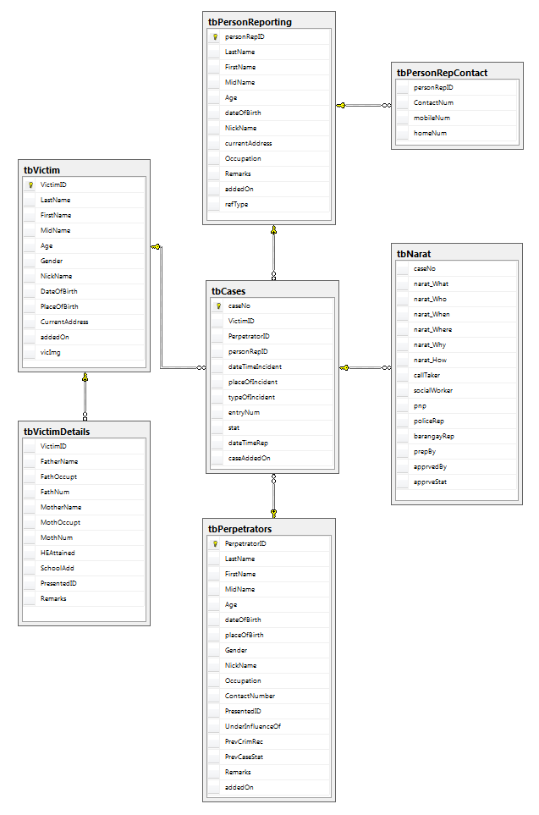
- PHYSICAL DATABASE DESIGN

INDEXES
- Create Unique Clustered Index for Primary Keys

Entity Primary Key Attribute Index Name

tbVictim VictimID VictimID_index
tbPerpetrators PerpetratorID PerpetratorID_index
tbPersonReporting personRepID personRepID_index
tbCases caseNo caseNo_index

- Create Index for Non-Key Indexes

Entity Primary Key Attribute Index Name

REFERENTIAL INTEGRITY

- tbPersonReporting & tbPersonRepContact – Foreign Key Constraints

- Every tbPersonReporting must have a contact record in the tbPersonRepContact.

- VICTIM & VICTIM DETAILS - Foreign Key Constraints

- Every Victim must have a record in Victim Details

TRANSACTION MAP

